Security Operations Simulation Report

Windows Endpoint Adversary Emulation - Windows Defender

Report field | Your details
Case ID | CASE_ID12345678
Classification | Internal Training
Exercise date | Report date | 09/15/2026 | 09/29/2026
Target host | Environment | Windows SOC Simulation | Windows Server 2025
Conducted by | Exercise type | Taylor Jones | Blue Team SOC simulation
Defensive tools tested | Microsoft Windows Defender

1 Bottom Line Up Front
This hypothetical SOC simulation begins after malicious activity was identified on a Windows Server 2025 endpoint. Microsoft Defender detected and blocked multiple malicious artifacts between approximately 2:40 AM and 2:41 AM on September 15, 2026. The simulation included activity associated with credential access, process injection, PowerShell execution, and privilege escalation techniques. All identified artifacts were quarantined or removed. No lateral movement, command-and-control activity, or data exfiltration was observed during the exercise.

2 Screenshot Evidence

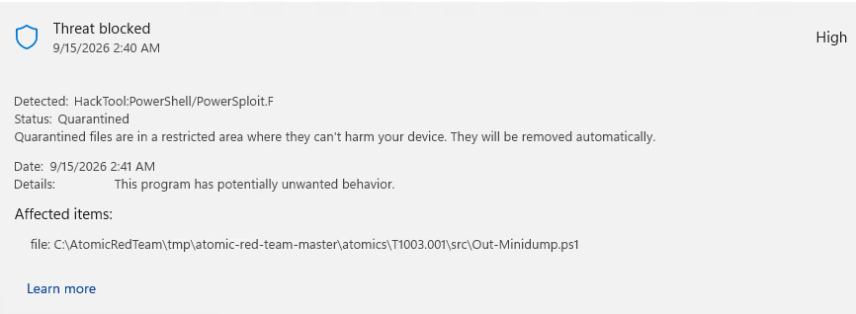
Figure 1 - Microsoft Defender detection of HackTool-PowerShell/PowerSploit.F (Out-Minidump.ps1; T1003.001 credential dumping). Severity: High. Status: Quarantined.

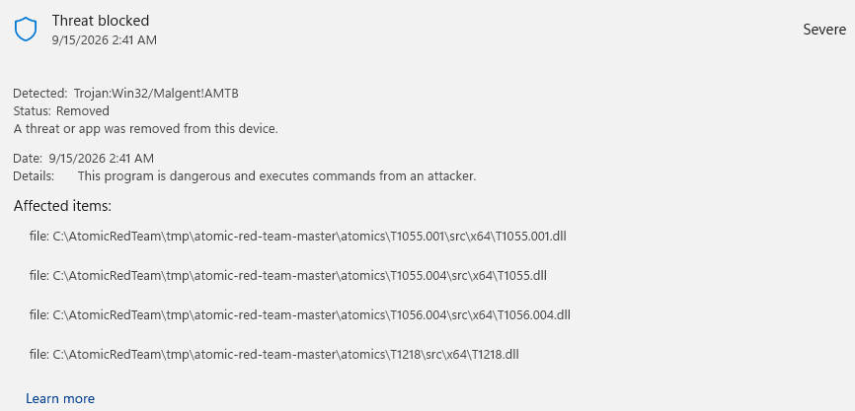

Figure 2 - Microsoft Defender detection of Trojan:Win32/Malgent!AMTB across four DLL files associated with the simulated activity. Severity: Severe. Status: Removed.

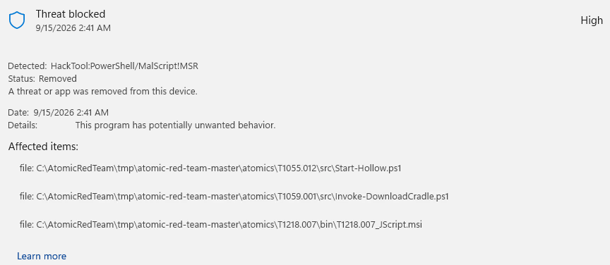
Figure 3 - Microsoft Defender detection of HackTool:PowerShell/MalScript!MSR affecting three files associated with PowerShell and trusted-process execution. Severity: High. Status: Removed.
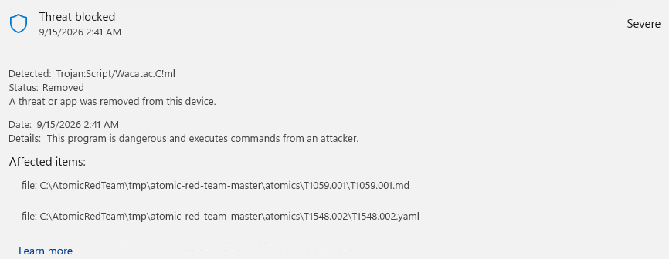
Figure 4 - Microsoft Defender detection of Trojan:Script/Wavatac.C!ml affecting T1059.001.md and T1548.002.yaml. Severity: Severe. Status: Removed.

3 Evidence of Activity

3.1 Alerts, Files, and Events Detected
Detection or event | Severity, status, and ID | Artifact or file path
HackTool-PowerShell/PowerSploit.F | High, Quarantined, T1003.001 | \atomics\T1003.001\src\Out-Minidump.ps1
Trojan:Win32/Malgent!AMTB | Severe, Removed, T1055.001, T1055.004, T1056.004, T1218 | \atomics\T1055.001\src\x64\T1055.dll,  \atomics\T1055.004\src\x64\T1055.dll,  \atomics\T1056.004\src\x64\T1056.004.dll,  \atomics\T1218\src\x64\T1218.dll
HackTool:PowerShell/MalScript!MSR | High, Removed, T1055.012, T1059.001, T1218.007 | \atomics\T1005.012\src\Start-Hollow.ps1,  \atomics\T1059.001\src\Invoke-DownloadCrade.ps1,  \atomics\T1218.007\bin\T1218.007_Jscript.msi
Trojan:Script/Wavatac.C!ml | Severe, Removed, T1059.001, T1548.002 | \atomics\T1059.001\T1059.001.md,  \atomics\T1548.002\T1548.002.yaml

3.2 Timeline of Actions
Timestamp and time zone | Action or event | Source
9/15/26 2:40AM EST | Defender blocked HackTool-PowerShell/PowerSploit.F and quarantined the payload. | Windows Defender
9/15/26 2:41AM EST | Defender blocked Trojan:Win32/Malgent!AMTB and removed 4 DLLs, injection/input capture. | Windows Defender
9/15/26 2:41AM EST | Defender blocked HackTool:PowerShell/MalScript!MSR, administrator hacking tool, blocking 2 file scripts and 1 package installation. | Windows Defender
9/15/26 2:41AM EST | Defender blocked Trojan:Script/Wavatac.C!ml and removed malicious scripts. | Windows Defender
9/15/26 02:42AM EST | Remediation efforts finalized; all listed artifacts were quarantined or removed. | Windows Defender

3.3 Files and Hash Review
File | SHA-256 | Priority
Out-Minidump.ps1 | Pending | Critical
T1055.dll | Pending | High
T1056.004.dll | Pending | Critical
T1218.dll | Pending | High
Start-Hollow.ps1 | Pending | High
Invoke-DownloadCrade.ps1, | Pending | Medium
T1218.007_Jscript.msi | Pending | High
T1059.001.md | Pending | Low
T1548.002.yaml | Pending | Low

Because this was a simulated exercise, SHA-256 hashes were not collected. During a real incident, file hashes would be collected and analyzed using approved threat-intelligence sources.

3.4 Host, User, and Network Indicators
Category | Value and evidence
Affected host and account | Administrator test account
IP address or domain | N/A as this was a testing environment.
Lateral movement | None observed
Data exfiltration | None observed

4 Findings and MITRE ATT&CK Mapping
This hypothetical SOC simulation was designed for investigation and reporting practice. There was no real threat actor. The observed activity was reviewed and mapped to MITRE ATT&CK techniques to illustrate the simulated attack chain.
Mapped techniques:
- Credential Access: (T1003.001) OS Credential Dumping of LSASS memory using Out-Minidump used to access and harvest credentials.
- Defense Evasion: (T1055.001, T1055.004, T1056.004, T1218); adversary is using a trusted windows binary to execute malicious code, injecting into legitimate processes (DLLs) APC queuing to hide from being detected, and hooking system APIs to steal credentials.
- Defense Evasion/Execution: (T1055.012, T1059.001, T1218.007) runs malicious PowerShell scripts through trusted Microsoft installer to hijack legitimate system processes, removing memory, and replacing with malware.
- Privilege Escalation: (T1059.001, T1548.002) runs malicious PowerShell commands to bypass Windows User Access Control, elevating privileges.

4.1 Detection Gap Assessment
This simulation tested Microsoft Windows Defender against living-off-the-land techniques. Defender identified and blocked the known malicious artifacts used in the exercise; however, the simulation also highlights the importance of additional visibility for activity involving memory injection and trusted Windows binaries.
- Windows binaries: The simulation used a trusted Microsoft installer to execute malicious scripts.
- PowerShell activity: The simulation included malicious PowerShell execution and process-manipulation behavior.
- Privilege escalation: The simulation included activity intended to bypass UAC controls and obtain elevated privileges.

5 Recommended Actions

5.1 Immediate Actions
- Segment the affected workstation from the rest of the network to support containment.
- Review Defender alerts and confirm that all identified malicious artifacts were quarantined or removed; terminate any remaining malicious processes if necessary.
- Check for persistence mechanisms, including newly created services, scheduled tasks, and registry run keys.
- Revoke and reset potentially compromised credentials.
- Collect and preserve relevant evidence for further analysis.

5.2 Longer-Term Improvements
- Harden UAC and administrative controls.
- Restrict unnecessary use of living-off-the-land binaries.
- Limit PowerShell access to authorized users and apply appropriate execution controls.
- Use EDR and memory-protection capabilities to improve endpoint visibility and detection.

6 Lessons Learned
- Track detection, response, and containment times during future simulations to evaluate incident-response performance.
- Collect file hashes and relevant indicators of compromise (IOCs) during the incident when available.
- Use EDR and SIEM tools to centralize monitoring and support timely alerting.
- Ensure appropriate team members are familiar with the incident-response playbook and their responsibilities during simulated events.

